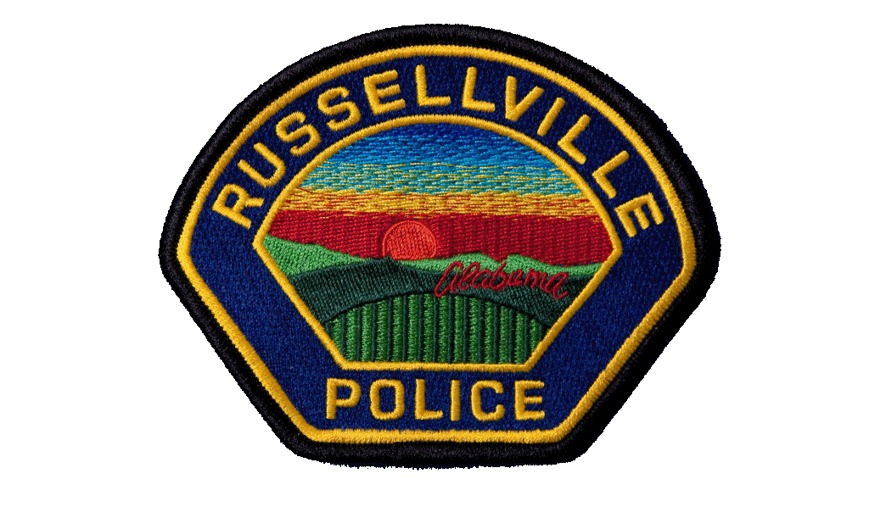
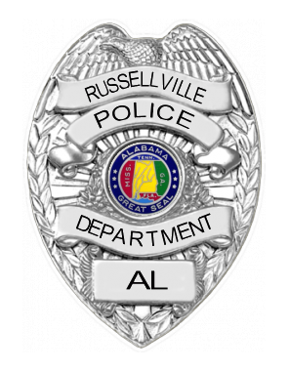

Date:
Time:
Case#:

Name: Date of Birth:

SSN: RACE: SEX: Education:

READ: Write:

Address:

Phone: Employer:

Employer Phone: Employer Address:

I DELCARE THAT THE FOLLOWING VOLUNTARY STATEMENT IS MADE OF MY OWN FREE WILL WITHOUT PROMISE OF HOPE OR REWARD, WITHOUT FEAR OR THREAT OF PHYSICAL HARM, WOTHOUT COERCION, FAVOR OR OFFER OF FAVOR, WITHOUT LENIECY, BY ANY PERSON OR PERSONS WHOMSOEVER.

I HAVE READ EACH PAGE OF THIS STATEMENT CONSISTING OF ____ PAGES(S), EACH OF WHICH BEARS MY SIGNATURE, AND CORRECTIONS, IF ANY BEAR MY INTIALS AND I CERTIFY THAT THE FACTS CONTAINED HEREEIN ARE TRUE AND CORRECT. I FURTHER CERTIFY THAT I MADE NO REQUEST FOR THE ADVICE OR PRESENCE OF A LAWYER BEFORE DURING ANY PART OF THIS STATEMENT, NOR AT ANY TIME BEFORE IT WAS FINSIHED DID I REQUEST THAT THIS STATEMENT BE STOPPED. I ALSO DECLARE THAT I WAS NOT PROMPTED WHAT TO SAY IN THIS STATEMENT.

THIS STATEMENT WAS COMPLETED __________ ON THE _______________ OF______________, 20___

SIGNATURE:
WITNESS: WITNESS:

